**Project Design Phase-II**

**Data Flow Diagram & User Stories**

|  |  |
| --- | --- |
| Date | 30 june 2025 |
| Team ID | LTVIP2025TMID54301 |
| Project Name | OrderOnTheGo: Your On-Demand Food Ordering Solution |
| Maximum Marks | 4 Marks |

**Data Flow Diagrams:**

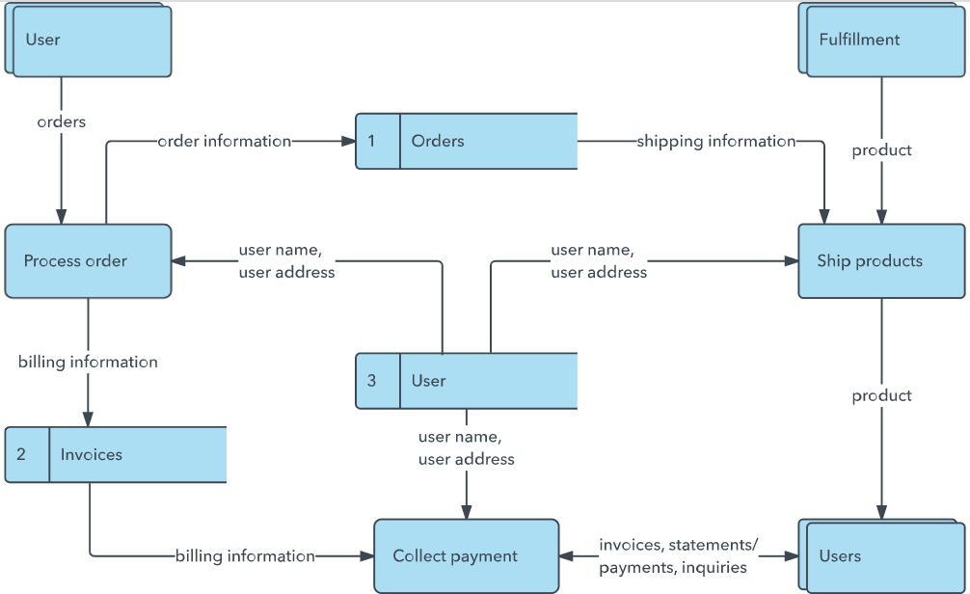A Data Flow Diagram (DFD) is a traditional visual representation of the information flows within a system. A neat and clear DFD can depict the right amount of the system requirement graphically. It shows how data enters and leaves the system, what changes the information, and where data is stored.

**Example:** [**(Simplified)**](https://developer.ibm.com/patterns/visualize-unstructured-text/)

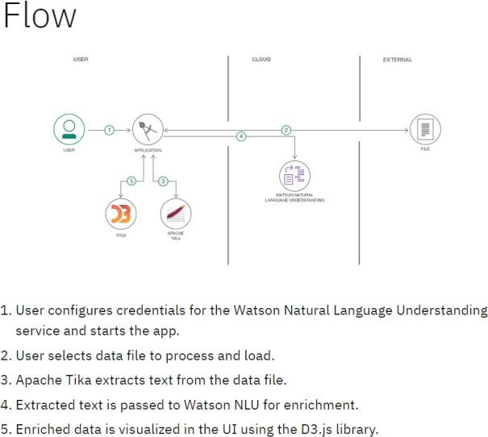

**User Stories**

Use the below template to list all the user stories for the product.

|  |  |  |  |  |  |  |
| --- | --- | --- | --- | --- | --- | --- |
| **User Type** | **Functional Requirement (Epic)** | **User Story**  **Number** | **User Story / Task** | **Acceptance Criteria** | **Priority** | **Release** |
| **Customer (Mobile user)** | **Registration** | **USN-1** | **As a user, I can register for the application by entering my email, password, and confirming my password.** | **I can access my account / dashboard** | **High** | **Sprint- 1** |
|  |  | **USN-2** | **As a user, I will receive a confirmation email once I have registered for the application.** | **I can receive a confirmation email & click confirm** | **High** | **Sprint- 1** |
|  |  | **USN-3** | **As a user, I can register for the application**  **through Facebook.** | **I can register & access the dashboard with Facebook Login** | **Low** | **Sprint- 2** |
|  |  | **USN-4** | **As a user, I can register for the application**  **through Gmail.** | **I can use my Gmail account to register and access my dashboard** | **Medium** | **Sprint- 1** |

|  |  |  |  |  |  |  |
| --- | --- | --- | --- | --- | --- | --- |
| **User Type** | **Functional Requirement (Epic)** | **User Story**  **Number** | **User Story / Task** | **Acceptance Criteria** | **Priority** | **Release** |
|  | **Login** | **USN-5** | **As a user, I can log into the**  **application by entering email & password.** | **I can log in and access my**  **account/dashboard** | **High** | **Sprint- 1** |
|  |  | **USN-6** | **As a user, I can reset my password using "Forgot Password" option.** | **I receive a reset link via email and can reset successfully** | **High** | **Sprint- 2** |
|  | **Dashboard** | **USN-7** | **As a user, I can view a personalized homepage showing nearby restaurants and offers.** | **Homepage loads restaurants based on my location and preferences** | **High** | **Sprint- 2** |
|  |  | **USN-8** | **As a user, I can add items to my cart and proceed to checkout.** | **Selected items are reflected in cart and checkout works smoothly** | **High** | **Sprint- 2** |
| **Customer (Web user)** | **Login & Browse** | **USN-9** | **As a user, I can log in from the web portal and search for food based on cuisine or location.** | **I get relevant search results on the web portal** | **Medium** | **Sprint- 3** |
|  | **Order History** | **USN-10** | **As a user, I can view my previous orders in my account dashboard.** | **List of past orders with status and date appears correctly** | **Medium** | **Sprint- 3** |
| **Customer Care Executive** | **Support**  **Dashboard** | **USN-11** | **As a support executive, I can view active user issues and respond through a ticketing system.** | **I can see user queries and reply through the dashboard** | **High** | **Sprint- 4** |

|  |  |  |  |  |  |  |
| --- | --- | --- | --- | --- | --- | --- |
| **User Type** | **Functional Requirement (Epic)** | **User Story**  **Number** | **User Story / Task** | **Acceptance Criteria** | **Priority** | **Release** |
|  | **Order Tracking**  **Assistance** | **USN-12** | **As a support executive, I can check order status and guide**  **customers on their delivery status.** | **I can see live order details and update the user if needed** | **High** | **Sprint- 4** |
| **Administrator** | **User Management** | **USN-13** | **As an admin, I can add, delete, or update user roles and permissions.** | **Changes reflect**  **instantly in the system** | **High** | **Sprint- 4** |
|  | **Restaurant Management** | **USN-14** | **As an admin, I can approve or remove restaurant accounts and view reports.** | **Approved restaurants show on platform; removed ones are hidden** | **High** | **Sprint- 4** |
|  | **Analytics Dashboard** | **USN-15** | **As an admin, I can view system-wide reports like total orders, top-selling items, and revenue.** | **Accurate statistics and graphs are generated** | **Medium** | **Sprint- 5** |